Author: Natalio Gomes

Week Three Problems

Ice Cream Parlor

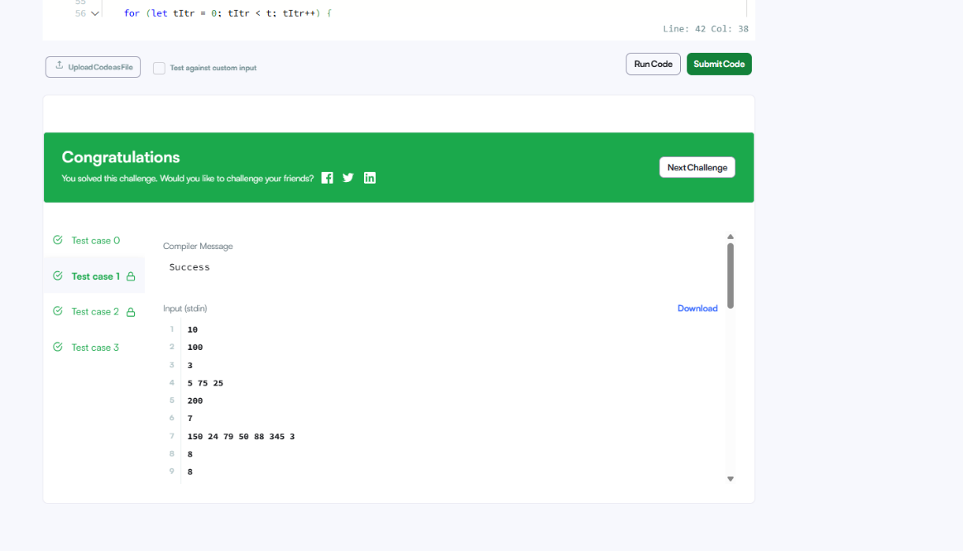

Recursive Digit Sum

